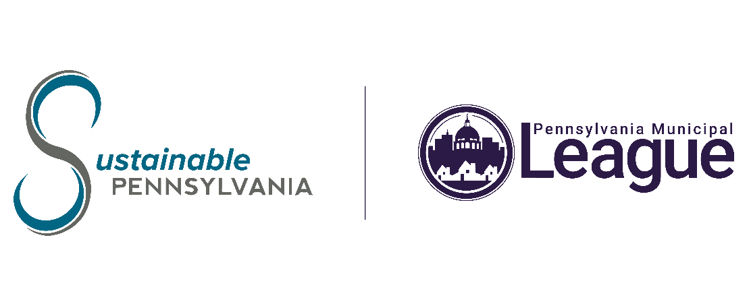
NEWS RELEASE
FOR IMMEDIATE RELEASE

TO NEWS/CITY DESK EDITOR

CONTACT: Debbie Bitting, Director of Communications, 717-236-9469, ext. *223; dbitting@pml.org

The League Holds Annual Sustainable PA Conference in Gettysburg

Harrisburg, PA (November 3, 2023) — The Pennsylvania Municipal League (The League) held its annual Sustainable PA Conference November 1-3, at the Wyndham Gettysburg. The conference brought in municipal officials from across the state to learn about sustainable practices in Pennsylvania and to explore ways to reach local community energy emissions reduction goals. The Sustainable PA Annual Conference is dedicated to guiding municipalities through the comprehensive process of developing local climate action plans, a critical prerequisite for unlocking federal grants and funding opportunities to support community initiatives.

We were pleased to have as our special guest Miss Pennsylvania Miranda Moore, who joined us for the welcome session and the panel discussion, Gathering Data and Setting Goals, as a sustainability professional and environmental engineer for UGI.

Practical and applicable sessions were held over the three days including: a Rain Barrel Making Workshop; Creating Buy-In, Gathering Data and Setting Goals; Fund It; Plan It; Implement It; Track and Report It; Conservation Considerations for Siting, Planning, and Maintaining Grid-Scale Solar Systems in Pennsylvania; as well as a Roundtable Work Session and a Sustainable Pennsylvania Certification Program Overview.

“The Sustainable Pennsylvania Certification Program is FREE to all municipalities in our state and helps local officials and community partners track real progress toward sound management and fiscal practices, environmental awareness and good stewardship of public assets and resources,” said League Executive Director John Brenner.

In addition to the educational sessions, attendees were able to talk with business vendors regarding sustainable solutions, programs, and products they have to offer.

The League and Sustainable Pittsburgh created the Sustainable Pennsylvania Community Certification, a voluntary performance recognition program designed to help municipalities achieve sustainability goals, which in turn will allow them to save money, conserve resources, and encourage innovation. The program is intended to bring recognition to municipalities that are applying the policy and practice of sustainability; municipalities that incorporate sustainable practices into their operations also foster community prosperity. The program provides communities with an online structure and performance platform for recognition as they adopt sustainable policies and practices. For more information, please visit SustainablePA.org.

# # #

The mission of the Pennsylvania Municipal League is to strengthen, empower and advocate for effective local government. The League is a nonprofit, nonpartisan organization established in 1900 as an advocate for Pennsylvania’s 3rd class cities. Today, The League represents Pennsylvania cities, boroughs, townships, and home rule communities that all share their municipal policy interests. The Board of Directors oversees the administration of a wide array of municipal services including legislative advocacy (on both the state and federal levels), publications designed to educate and inform, inquiry and research, education and training certification programs, consulting-based programs, and group insurance trusts. For more information, please visit PML.org. Join the conversation on Twitter @PAMunicipalLeag, facebook.com/PaMunicipalLeague, and LinkedIn − #SustainableConf23, #StrengthThroughEngagement.

