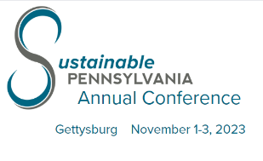

2023 Exhibitor Information

Electric
Please complete the AV/Electric Order Form from the hotel. Electric is $35 for 120v (extension cords/power strips are not included).

Exhibit Booth Set-Up

Wyndham Gettysburg | Salon D | 1st Floor
Wednesday, November 1 – 1:00 p.m. – 3:00 p.m.  Thursday, November 2 – 6:00 a.m. – 8:00 a.m.
Tabletop booth spaces are 8’ wide x 4’ deep, include two chairs and complimentary Wi-Fi.

Exhibitor Registration

Wyndham Gettysburg | Salon DEF Hallway | 1st Floor
Wednesday, November 1 – 1:00 pm – 6:00 pm
Thursday, November 2 – 8:00 a.m. - 3:00 p.m.

Welcome Cocktail Reception

Wyndham Gettysburg │ Salon D | 1st Floor (Exhibit Hall)
Wednesday, November 1- 5:00 – 6:00 p.m.

Exhibit Hall Open to Conference Attendees
Wednesday, November 1– 3:00 – 6:00 p.m.  Thursday, November 2 – 7:30 a.m. - 3:00 p.m.
(All breaks are scheduled in the exhibit hall.)

Exhibit Tear-Down
Thursday, November 2 – 3:00 p.m. – 5:00 p.m.

Mobile Conference App
Whova is the mobile event management app provider for the Conference.
Additional information will be available shortly.

Additional Exhibitors
Each exhibit booth is entitled to two exhibitors. Additional exhibitor badges are available for $175.
A Conference badge is required for each exhibitor.

Sponsorship
Opportunities will be available for exhibitors to sponsor the app, workshop, reception, and meals. In addition to the exhibitor booth, sponsorship will allow a speaking opportunity during the sponsored event.
Thank you for your participation!

