Building a Better America Toolkit
  - For State & Local Leaders

Contents

Purpose 2
Resources 2
Event Ideas Based on Theme 3
Sample Weekly Planning 3
Event Planning and Digital/Earned Media Checklist 4
Sample Talking Points Based on Theme 5
Logos, Branding, and Style Guide 10
Style Guide 11

Purpose
Building A Better America is at the heart of the President’s infrastructure agenda. This toolkit includes useful branding, messaging, and a style guide to assist YOUR efforts to amplify specific components of President Biden’s Bipartisan Infrastructure Law through earned media, digital media, and in-person public events underscoring the historic investments that the American Rescue Plan Act (ARP) and President Biden’s Infrastructure Law (BIL) will continue to bring to the American people. We want to engage all of you early on, but will also keep you apprised of major funding announcements in the coming weeks, months, and even years.

Resources

White House and Federal Agency Resources
  - Build.gov
  - President Biden's Bipartisan Infrastructure Law
  - The Biden-Harris Electric Vehicle Charging Action Plan
  - The Bipartisan Infrastructure Law Advances Environmental Justice
  - President Biden’s Bipartisan Infrastructure Law Advances Economic and Public Health Opportunities for Tribal Communities
  - The Bipartisan Infrastructure Law Will Revitalize Main Street
  - The Biden-Harris Lead Pipe and Paint Action Plan

U.S. Department of Transportation
- USDOT Releases State by State Fact Sheets Highlighting Benefits of the Bipartisan Infrastructure Law
- FHWA’s Longterm Bridge Performance (LTBP) Program Portal
- FHWA press release (see below for draft, final will be released on January 14)
- FHWA map of bridges in poor repair and funding by state (to be released day of)

U.S. Environmental Protection Agency
- EPA Announces Water Infrastructure Funding for States Through the Bipartisan Infrastructure Law, Calls for Prioritizing Underserved Communities

More resources will be disseminated as announcements are made.

Event Ideas Based on Theme

January Themes
- January 14th Kick-Off – Fixing and Rebuilding Bridges
- Week of Jan 17 – Fixing and Rebuilding Bridges (continued)
- Week of Jan 24 – Improving Travel Safety
- Week of Jan 31 – Strengthening Ports & Expanding EV Infrastructure

Sample Weekly Planning

Over the course of each week, consider the following types of activity according YOUR state or local government schedule. For example:
- Monday: Federal agency briefing
- Tuesday: Press release or paper statements
- Wednesday/Throughout Week: Social and digital activity
- Thursday: State or local press call
- Friday: In person message event that garners local earned media

Event Planning and Digital/Earned Media Checklist

While we know you are already pros at this, allow us to make another ask – please consider leveraging all your communications and digital platforms in order to elevate your programming on the BIL and ARP! Consider these potential items:

Checklist
- Determine event concept based on week’s theme
- Identify an event location
- Finalize relevant press list
- Identify speakers list and talking points
- Lock in event time, location, and speakers
- Schedule event and logistics prep time
- Schedule speaker prep time
- Draft and send press advisory
- Draft and send newsletter and/or post website blurb
- Develop a social media plan (livestream, draft Tweets and Facebook posts)
- Confirm local news and if relevant with coalitions or constituency media outlets
- Post event:
  - Draft and send event re-cap with media clips and social media amplification

State and Local Considerations
When planning for the theme week’s engagement, consider state and local agencies you can partner with, in addition to constituents, businesses, schools, or unions who would benefit from BIL. Check out this example for the Friday, January 14 Kick-Off:

Example for Week 1: Fixing and Repairing Roads and Bridges

Host an event near a bridge that could be fixed: To draw local media attention, YOU can host a press conference at a bridge in your state that stands to benefit from the Bipartisan Infrastructure Law’s funding.
- Consult with YOUR state DOTs: USDOT’s announcement will be formula funding for the state. It does not specify which bridges will get repaired. However, YOU can work with your State Department of Transportation (DOT) DOT to identify a bridge they plan to repair with this investment and host an event at that bridge.
- Consider local impacts: Identify people or industries that rely on the bridges, such as for getting to work/school every day or moving goods. Find ways to lift up their stories in terms of what this means for them.
- Ideas for speakers at the event:
  - Elected officials
  - Labor union that could benefit from the jobs created.
  - State DOT/ city representative
  - Organization/ company that stands to benefit as a result of the bridge being repaired.
  - Local worker affected by traffic, congestion, or detours

Sample Talking Points Based on Theme

Week of January 14th Kick Off & Week of January 17, 2022
Fixing and Rebuilding Bridges

- The Bipartisan Infrastructure Law makes the single largest investment in repairing and reconstructing our nation’s bridges since the construction of the interstate highway system.
- Investments from the Bipartisan Infrastructure Law (BIL) will not only repair and rebuild our roads and bridges but it will do so with a focus on addressing climate change, creating more resilient communities, uplifting our most vulnerable communities, and enhancing safety for all people.
- In the United States, 1 in 5 miles of highways and major roads, and 45,000 bridges, are in poor condition.
- The legislation reauthorizes surface transportation programs for five years and invests $110 billion in additional funding to repair our roads and bridges and support major, transformational projects.
- It will rebuild the most economically significant bridges in the country as well as thousands of smaller bridges.
- The legislation also includes the first ever Safe Streets and Roads for All program to support projects to reduce traffic fatalities, which claimed more than 20,000 lives in the first half of 2021.

Bridge Formula Program Announcement on Jan 14, 2022
- On January 14, the U.S. Department of Transportation’s Federal Highway Administration (FHWA) will announce the largest bridge formula program in American history, made possible by the Bipartisan Infrastructure Law.
- As a result of the Bipartisan Infrastructure Law, the Bridge Formula Program will dedicate $26.5 billion to states, the District of Columbia, and Puerto Rico over the five years of the law and $825 million for Tribal transportation facilities.
- Nationwide, the program is expected to help improve as many as 15,000 highway bridges. Additionally, the program dedicates funding for Tribal transportation facility bridges as well as “off-system” bridges, which are generally locally owned facilities not on the federal-aid highway system.

Social Media Examples
- President Biden: “Folks, if you traveled for the holidays you probably saw America’s crumbling roads and bridges firsthand. We’re changing that with the Bipartisan Infrastructure Law — investing in America and creating millions of good-paying, union jobs at the same time.” [Tweet, 12/28/21]
- Governor Laura Kelly (KS): “The Bipartisan Infrastructure Deal will: Transform our roads and bridges, Modernize our airports, Expand high-speed internet access, Replace our lead pipes, and Upgrade our wastewater system. It's commonsense, good policy that will grow our economy.” [Twitter, 11/15/21]
Week of January 24, 2022
Improving Travel Safety

Public Transit
- The Bipartisan Infrastructure Law (BIL) will improve transportation options for millions of Americans and reduce greenhouse emissions through the largest investment in public transit in U.S. history.
- America’s public transit infrastructure is inadequate – with a multibillion-dollar repair backlog, representing more than 24,000 buses, 5,000 rail cars, 200 stations, and thousands of miles of track, signals, and power systems in need of replacement.
- Communities of color are twice as likely to take public transportation and many of these communities lack sufficient public transit options.
- And the transportation sector in the United States is now the largest single source of greenhouse gas emissions.
- Fortunately, the Bipartisan Infrastructure Law includes $39 billion of new investment to modernize transit, in addition to continuing the existing transit programs for five years as part of surface transportation reauthorization.
- In total, the new investments and reauthorization in the BIL provide $89.9 billion in guaranteed funding for public transit over the next five years — the largest Federal investment in public transit in history.
- The legislation will expand public transit options across every state in the country, replace thousands of deficient transit vehicles, including buses, with clean, zero emission vehicles, and improve accessibility for the elderly and people with disabilities.

Passenger Rail
- The Bipartisan Infrastructure Law will also make the largest investment in passenger rail since the creation of Amtrak.
- U.S. passenger rail lags behind the rest of the world in reliability, speed, and coverage. China already has 22,000 miles of high-speed rail, and is planning to double that by 2035.
- The Bipartisan Infrastructure Law positions rail to play a central role in our transportation and economic future, investing $66 billion in additional rail funding to eliminate the Amtrak maintenance backlog, modernize the Northeast Corridor, and bring world-class rail service to areas outside the northeast and mid-Atlantic.
- This is the largest investment in passenger rail since Amtrak’s creation, 50 years ago and will create safe, efficient, and climate-friendly alternatives for moving people and freight.
- The BIL includes new provisions to prevent operator assaults built on collective bargaining and labor-management collaboration, so that no transit worker should fear for their safety just for doing their job.

Social Media Examples
- President Biden: “The Bipartisan Infrastructure Law… makes the most significant investment in passenger rail in the past 50 years and in public transit — ever. That means you’ll be safer and get places faster.” [Twitter, 11/16/21]
- Indiana Senator J.D. Ford: “Thank you @RepAndreCarson for passing the forward-thinking #IIJA. Record rail funding will improve safety, address local crossing issues, make passenger service more accessible, and deliver a more sustainable future.” [Twitter, 11/18/21]
- Mayor London Breed, San Francisco, CA: “Local dollars alone are not enough. We need help. And this infrastructure bill will not only help San Francisco, but this entire country, so that we can improve safety in our streets, especially in major cities like San Francisco, where you have seen a significant increase in people walking and biking.” [Statement, 12/21/21]

Week of January 31, 2022

Strengthening Ports & Expanding EV Infrastructure

Airports and Ports
- The Bipartisan Infrastructure Law (BIL) will upgrade our nation’s airports and ports to strengthen our supply chains and prevent disruptions that have caused inflation.
- This will improve U.S. competitiveness, create more and better jobs at these hubs, and reduce emissions.
- Decades of neglect and underinvestment in our infrastructure have left the links in our goods movement supply chains struggling to keep up with our strong economic recovery from the pandemic.
- The BIL will make the fundamental changes that are long overdue for our nation’s ports and airports so this will not happen again.
- The United States built modern aviation, but our airports lag far behind our competitors. According to some rankings, no U.S. airports rank in the top 25 of airports worldwide. Our ports and waterways need repair and reimagination too.
- The BIL invests $17 billion in port infrastructure and waterways and $25 billion in airports to address repair and maintenance backlogs, reduce congestion and emissions near ports and airports, and drive electrification and other low-carbon technologies.
- Modern, resilient, and sustainable port, airport, and freight infrastructure will strengthen our supply chains and support U.S. competitiveness by removing bottlenecks and expediting commerce and reduce the environmental impact on neighboring communities.

Social Media Examples:
- President Biden: “With the Bipartisan Infrastructure Law, we will once again have the best roads, bridges, ports, and airports. We will lead the world into the 21st century with modern cars and trucks and transit systems. We will be building and moving again.” [Twitter, 11/21/21]
- Mayor Jenny Durkan, Seattle, WA: "Thank you @POTUS & @USDOT for making #infastructureweek a real thing! The Bipartisan Infrastructure Deal will transform our region and country with investments like $17B for critical ports like @PortofSeattle to help address nationwide supply chain issues.” [Twitter, 11/10/21]
- Mayor Libby Schaaf, Oakland, CA: "Another gem of the Bipartisan Infrastructure Deal is that invests heavily in our nation's ports, like Oakland's, to modernize + expand our freight networks -- which moves goods and unclogs supply chains. #BuildBackBetter" [Tweet, 11/9/21]

Electric Vehicles
- The Bipartisan Infrastructure Law will build a national network of electric vehicle (EV) chargers.
- U.S. market share of plug-in EV sales is only one-third the size of the Chinese EV market. That needs to change.
- The BIL will invest $7.5 billion to build out a national network of EV chargers in the United States. This is a critical step in the President’s strategy to fight the climate crisis and it will create good U.S. manufacturing jobs.
- The BIL will provide funding for deployment of EV chargers along highway corridors to facilitate long-distance travel and within communities to provide convenient charging where people live, work, and shop.
- This investment will support the President’s goal of building a nationwide network of 500,000 EV chargers to accelerate the adoption of EVs, reduce emissions, improve air quality, and create good-paying jobs across the country.

Social Media Examples:
- President Biden: “This Bipartisan Infrastructure Law will for the first time ever create a true national network of charging stations for electric vehicles. That means you can charge up and drive across the country — and it’ll create thousands of jobs for electrical workers.” [Twitter, 11/17/21]
- Mayor LaToya Cantrell, New Orleans, LA: "The Bipartisan Infrastructure Deal Invests $7.5B in Electric Vehicle Charging infrastructure! New Orleans is already partnering with @EntergyNOLA to construct public EV Charging stations around the City We’re hopeful for more dollars to expand that program.:clap::muscle::fleur_de_lis:" [Twitter, 11/09/21]
- Connecticut State Senator Jorge Cabrera: “Great to join Congresswoman @rosadelauro, @WelanderforCT, @Porter4DaPeople, @LaurenGarrettCT, and @MayorElicker for a ride on a CT Transit electric battery bus. During the ride, we talked about the major funding coming to CT because of the federal infrastructure bill” [Twitter, 11/29/21]

Logos, Branding, and Style Guide

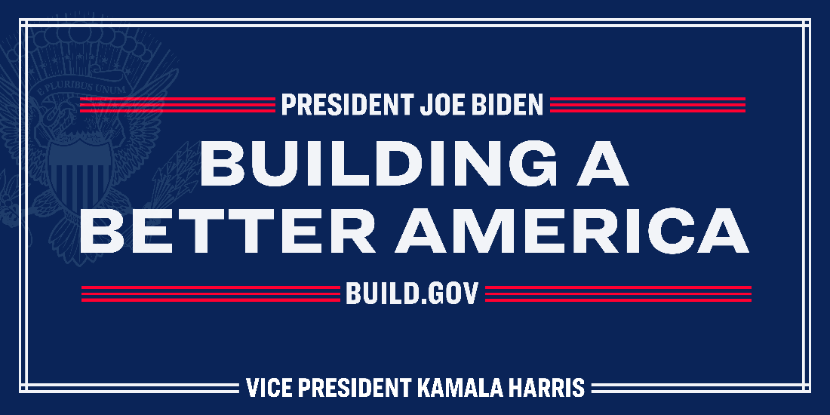

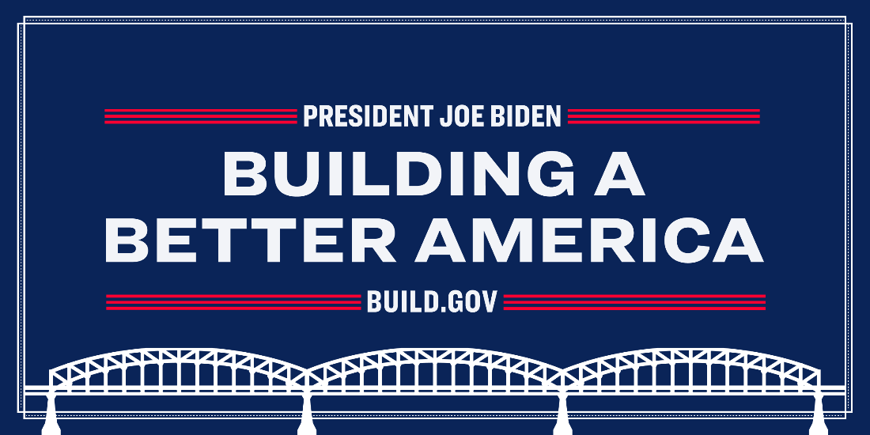

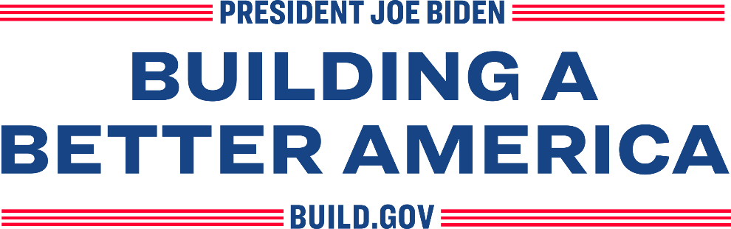

Style Guide

